Research Report: Traffic and Ride-Sharing Economics

1. The Mechanics of Traffic-Driven Pricing
Traffic congestion fundamentally alters the supply-and-demand equilibrium in the ride-sharing market. When cars are stuck in traffic, the available supply of drivers drops because each trip takes longer to complete. This shift directly impacts how platforms like Uber and Lyft price their services and manage their networks.

Key Pricing Mechanisms
Surge Pricing (Dynamic Pricing): When traffic slows the completion rate of trips, available drivers become scarce in congested areas. The system applies a surge multiplier to base fares to balance the market.
Time-Based Charges: Base fares are calculated using both distance and estimated time. Heavy traffic directly increases the time variable, raising the standard fare even before any surge multiplier is applied.
Wait Time Reduction: Higher prices intentionally reduce passenger demand, as some users choose to wait or seek alternative transit, preventing the network from failing entirely.

2. Visual Analysis: Supply & Surge Dynamics
The following chart illustrates the inverse relationship between traffic congestion and driver supply. As congestion approaches critical gridlock, driver availability drops precipitously, triggering an aggressive, non-linear increase in the surge multiplier to clear the market.
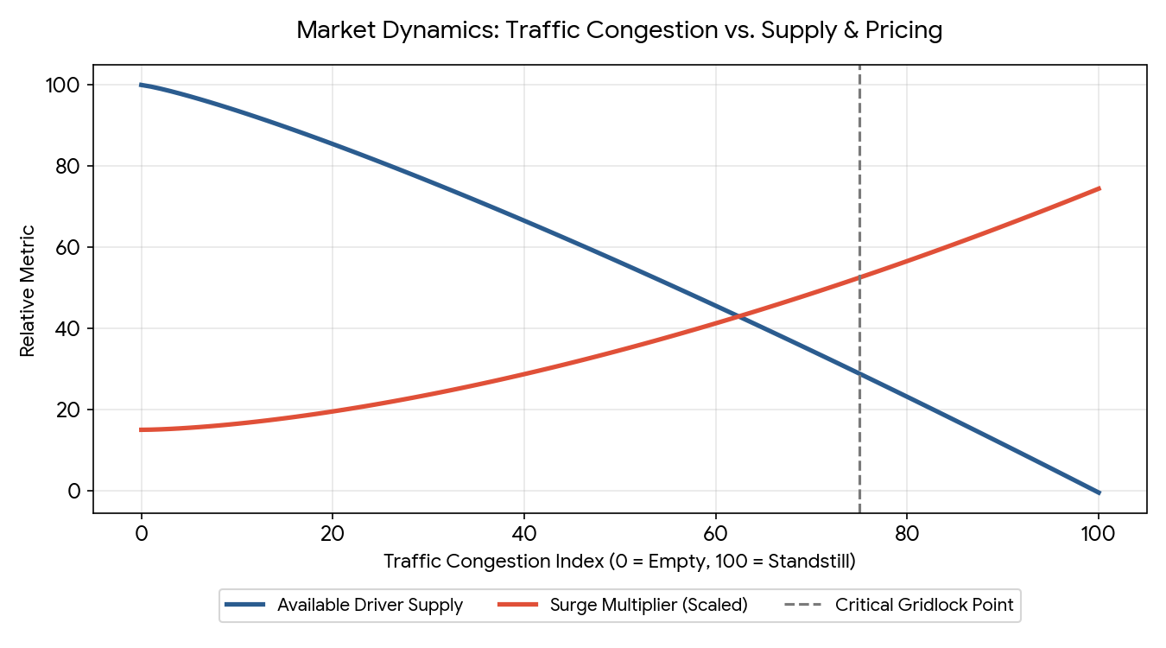

3. Impact on Stakeholders

Passengers
Passengers face higher upfront costs but gain the reliability of getting a ride when needed. Without price adjustments, wait times would skyrocket, leading to a "zero cars available" scenario.

Drivers
Surge multipliers incentivize off-duty drivers to log on. However, there is a "congestion penalty." While drivers earn higher rates per minute during a surge, severe gridlock limits the total number of trips they can complete in an hour, which can offset the benefits of the higher multiplier.

4. Business Economics for the Platform
For ride-sharing companies, traffic and the resulting surge pricing are crucial for market clearing rather than purely maximizing profit per ride. Uber uses dynamic pricing to protect the core value of its product: reliability. Furthermore, extreme surge periods (e.g., 3x or higher) are often "pain periods" for platforms. At extremely high prices, demand drops precipitously, meaning total ride volume—and consequently the platform's total service fee revenue—can actually decline compared to steady, moderate-demand periods.

